**Solutions - Assignment 2 - Pratik**

**Github Repo:** <https://github.com/pratix11/DevOpsLessons>

1. Grade Checker

Take a score as input and print the grade based on the following:

90+ : "A"

80-89 : "B"

70-79 : "C"

60-69 : "D"

Below 60 : "F"

here we used a basic if else statement to carry out marks and all.

- Wrote a code with if elif else looping statements to help find out the entered grades with a print statement

score = int(input("Enter your score: "))

if score > 90:

grade = "A"

elif score >= 80 and score <= 89:

grade = "B"

elif score >= 70 and score <= 79:

grade = "C"

elif score >= 60 and score <= 69:

grade = "D"

else:

grade = "F"

print("Your grade as per your mark is: " +grade)

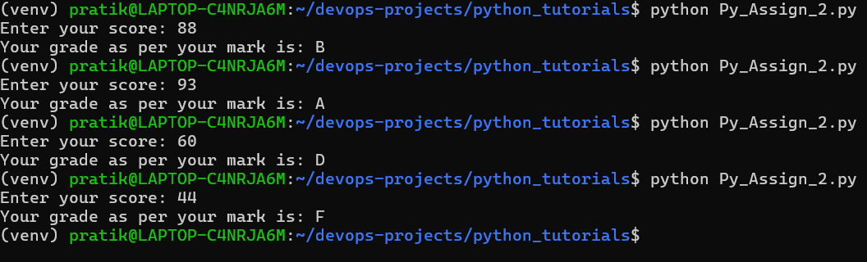

2 Student Grades

Create a dictionary where the keys are student names and the values are their grades. Allow the user to:

Add a new student and grade.

Update an existing student’s grade.

Print all student grades.

Used dictionary and basic operations. Using if else:  
- I made a dictionary with 4 students as key and values as their marks, first I printed their marks to let the user know what they are working with. Next, I asked which of these student’s marks they’d like to update, if it is a name from the dictionary, then existing student’s marks will be updated, if not a new student will be added to the dictionary, and that was done with help of if else statements.

students = {

'john' : 60,

'don' : 90, # type: ignore

'ron' : 88,

'kaun' : 34

}

print("This is the current class and their marks: ", students)

i = input("Whose marks would you like to update?\n")

if i in students:

students[i] = int(input("Please enter the marks for that student: "))

else:

students[i] = int(input("Please enter the marks for tthe new student: "))

print("This is the updated list of students: ", students)

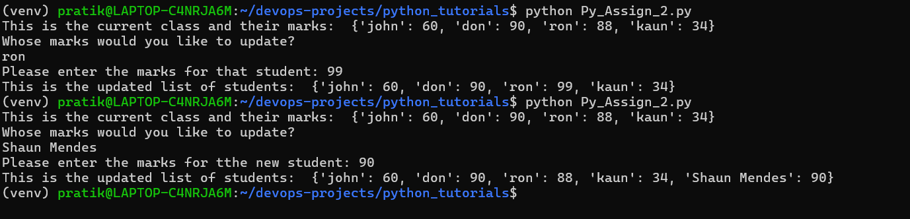

3.Write to a File

Write a program to create a text file and write some content to it.

Using file functions like write and open.  
  
4. Read from a File

We used open in read mode and file.read to read and print to display.

- I wrote a combined program for questions 3 and 4, as I opened the file in write mode, then I wrote to the file a line and then closed it using file close, I opened the file to showcase the read mode, which read the data and I printed it as well.

#Question 3 & 4

f = open('data_assign2.txt','w')

#Write to the file

f.write('This is harry potter new line')

f.close()

f = open('data_assign2.txt','r')

#print the data

data = f.read()

print(data)

f.close()

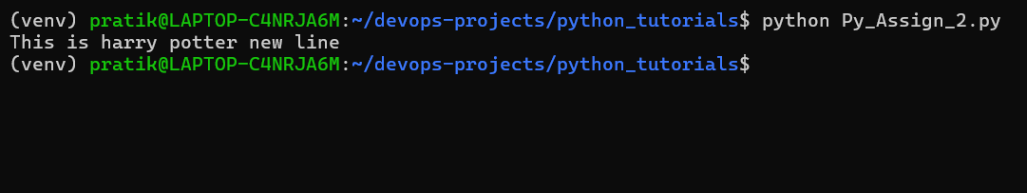

**Submission Guidelines -:** Attach Screenshots or command along with explanation and submit in doc(google doc or microsoft doc) format or share github link